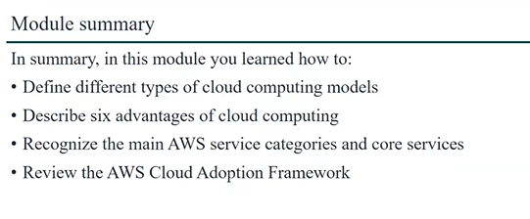

# Define different types of cloud computing models

## Infrastructure as a service: This model allows you to rent virtualized hardware instead of buying physical forms of the said hardware. It provides IT infrastructure such as, compute, storage and networking on a pay as you go basis.

## Platform as a service: is a model that provides platform for developers to use for the purpose of development, testing, deployment, running and managing applications without the complexity and challenges of hosting the underlying infrastructure.

## Software as a service: This is a cloud computing model in which applications or software are distributed by cloud providers for use by users over the internet.

# Describe the six advantages of cloud computing

## Cost Savings: Cloud computing eliminates the need for large upfront investments in hardware and infrastructure, meaning that organizations only have to pay for resources the use, thereby reducing capital expenditures and ongoing maintenance costs.

## Scalability and Flexibility: cloud resources and be easily scaled up or down on demand based on the amount of workload per time which therefore allows businesses to quickly adapt to quickly changing demands of the organization without over investing in resources. So, there is no need to guess capacity.

## Increased collaboration: cloud-based platforms facilitate seamless collaboration among teams, regardless of location. Meaning that files, documents and applications can be accessed and shared easily, thereby fostering better teamwork and productivity

## Faster speed and agility: providers of cloud services generally offer faster network performance and automatic updates, allowing for quicker deployment of applications and faster processing speeds than traditional on-premises systems.

## Enhanced security: Cloud providers invest heavily in security measures, including encryption at rest and encryption in transit of data and information in the cloud ecosystem, providing higher level of security for sensitive data than many organizations can achieve on their own.

## Go global in minutes: this helps users to be able deploy their applications or services in a very short time in order for the application to be available to users globally.

## Improved Disaster Recovery: Cloud computing simplifies disaster recovery by enabling organizations to easily back up data and applications and restore them in different geographical locations in the event of a disaster.

## Economy of scale: this is the scenario where companies that act as cloud providers buys large volumes of system resources and share them with several people who happen to be users of their service. And it works in such a way that the more people use the services of the cloud providers, the less people will have to pay for the services.